Al-Rowwad Cultural  & Theatre Training Centre  Aida Camp – Bethlehem |   Theatre  الرواد  مسرح  Al-Rowwad | مركز الرواد للثقافة  والتدريب المسرحي  مخيم عايدة – بيت لحم

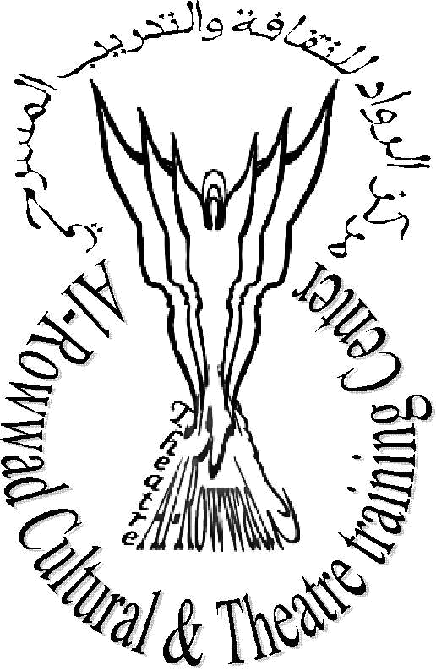

Images for Life Unit (IFLU) Activities:

Video Training Course:

- Mimi Nietula, a volunteer from Finland, started new video workshop at Alrowwad Center on July 1, 2008 that will continue until November 2008. Sixteen young participants are part of this training. The trainees are working through four groups who are supposed to produce their own documentary by the end of the training course that is covering both drama and fiction. The first part of the training dealt with theoretical aspects like basic concepts of documentary making and journalism, script writing, and interview techniques. Beside, they learnt basic video techniques, such as different shot sizes and angles. While the last part focused on editing techniques, especially the use of Adobe Premiere editing software. The participants are currently shooting, collecting information, editing and finalizing their documentaries. The titles of thymes of these movies are:
  - How Palestinian youths spend their time.
  - How worldwide inflation is hitting an already strained Palestinian economy.
  - How a young Palestinian boy flies his hand-made kite over the separation wall when he himself cannot travel beyond its confines.
  - How an elderly Palestinian joyously finds himself in his childhood home deep inside Israel, only to be shattered when he realizes it is only a dream.

- Mobile Video Training: from seventh to 18th of July 2008, the World Film Collective delivered a ten-day workshop of how to use mobile phones in producing movies at Alrowwad Center to sixteen young Palestinians. By the end of the training, Participants produced two films about their hopes, ambitions and the obstacles they face in their daily lives. They used their own mobile phones to shoot different scenes. Participants received a DVD copy of their film, along with an Arabic handbook about Mobile Phone Filming.

- Qattan Foundation Project “Midsummer Nights Film Festival”: This summer film festival is part of the classics of European cinema in Translation Project. Ten films were screened between August 18 - 26. The screenings took place at AlRowwad Center main hall. Some films were produced by Palestinians like “Little hands and the Cane” of Abdel Salam Shehadeh. While most of them were classical European films like “Modern Times” of Charlie Chaplin and “Letter from an Unknown Woman” of Max Ophuls. More then 30 people attended the opening night. While 15 – 20 people attended the remaining nights. An open discussion followed every screening.

- Alrowwad Center has just finished Moving Movies project that was supported by Hoping Foundation. We screened different films in ten refugee camps around the West Bank. Films from the history of world cinema screened at either outdoor or indoor free of charge and open to everyone in the community. The project was a great opportunity to bring cinema to isolated population that has no access to movie shows. The project helped to raise awareness of the importance of filmmaking as a tool of communication and resistance. Varieties of movies screened to different audience, for children we screened cartoons, such as “The Lion King”, “Ice Age” and “Toy Story”, for the adults, movies like “I am Sam” and “Million Dollar Baby” were screened. An open discussion followed each screening in which the audience, both children and adults had the opportunity to talk about the movie. On July 21, about 450 people attended the screening of two movies at Alam'ari and Jalazon camps in Ramallah area. On the 22nd about 100 children attended the screening in Balata and Al Ein camps in Nablus area. At Aqabat Jabr camp in Jericho, an audience of 120 girls aged 13 to 17 watched the movie. Another team of Alrowwad was busy screening a movie at AlFara'a camp for 300 children in a place were once stood an Israeli prison. On July 26, two camps from Hebron area AlFawwar and AlArroub screened two movies to a group of 100 kids. The last show was in Aida camp where tens of kids watched and discussed the last screened movies.

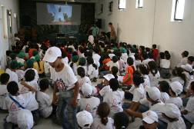

- “Breaking the Surface” documentary: Fran Tarr, a screenwriter and documentary filmmaker collaborated with IFLU to produce a documentary called “Breaking the Surface” during the first half of August. “Breaking the Surface” passionately, conveys the resilience of both Palestinian and American teenagers struggling with the adverse circumstances in their daily lives through their writing. It becomes clear these teenagers share a fear of failure, and an uncertain future overwhelmed by the call to revolutionize the environment in which they live. Through their writing, these teenagers demonstrate that they and their peers are not victims or predators but an integral, vulnerable part of the solution- dispelling misunderstandings and rectifying misconceptions. On an 18-day shoot, Fran guided ten AlRowwad students in the creation of an original collage play composed of their own writing, while exploring the identity of these teenagers separate to the tensions of their outside world. The high level of technical expertise and artistic vision of the Images for Life crew made “Breaking the Surface” a richer story. Once back in New York City Fran will begin filming the New York segment with students from Independence High School. “Breaking the Surface” will appear in film festivals around the world, HBO has expressed interest in viewing the final cut.

Art and Theatre Unit (ATU) Activities:

- Alrowwad Center has just finished its annual tour. This year the tour included France and Belgium. Twenty-one kids and three adults toured the two countries for 40 days where they performed in different towns and cities. The group consisted of actors and traditional Palestinian dancers. The theater group performed the play “Blame it on the Wolf” that was adopted and modified by Dr. Abdelfattah Abusour. The play tries to tackle stereotypes and the way they influence our behavior. While the dancing group amazed the audience every time, they took the stage by their beautiful performance. Trainings around the o'clock took place during weeks prior the tour to prepare the kids. Part of the work involved music composition and theatre décor. A new costume for the dancing group has been designed and prepared. The kids had more than 20 performances in several cities where thousands of people attended. It was a productive and meaningful tour in a sense of raising European about the daily life of Palestinians and showing them the true and beautiful image of them.

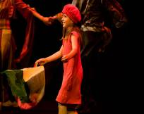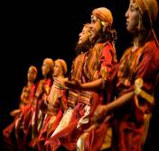

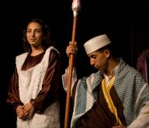

- As part of our continues support to other local organizations the clown group has performed to a group of 100 children in Bateer village that is located to the West of Bethlehem and surrounded by Israeli Settlements. The show took place during the month of august to support the work of a local organization there that help children with disabilities on the disabled international day.

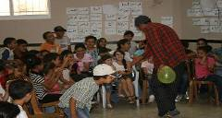

- Alrowwad Center hosted an Italian clown Mr. Biadro who came through Qattan Foundation and performed for a group of thirty kids from the camp. The idea of the show is to encourage kids to pursue their education and not to drop out of school. The show was highly interactive as the kids were included in the show.
- Alrowwad Center hosted in august a will known actress from Jerusalem Mrs. Doreen who performed two solo performance for different groups in Aida camp to raise their awareness about children rights. In addition, two French artists who came through the French consulate entertained a group of 150 children in a wonderful puppets show.

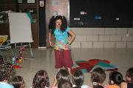

- The Italian Community Theatre visited Alrowwad Center and conducted a workshop in modern dance. The two trainers Mrs. Laura and Mr. Gigi trained six participants for three consecutive days of how to integrate the modern dance on our theatre and dabka shows.
- A new project of drawing has just started to teach children of basic skills of drawing and the use of different colors. Two volunteers from Aida and Hebron Mr. Mahmoud Abusrour and Hanin Abukhsoum are going to start the lessons this coming week. The idea came after we hosted two French volunteers who conducted a workshop for fifteen young people from the camp. The drawings that children made are going to be shown in France as part of exhibition they are planning to do.
- Because of the successful tour in France and the dedication and commitment of Mr. Osama Aljabri, the unit program manager tens of children are asking to join its activities. Currently the unit has 13 active groups; five theatre groups, two musical groups, three dancing groups, a newly formed hip-hop group, one drawing group, and one psychodrama group. Altogether, we have more than 70 kids involved on different activities. The center is very busy as we have trainings in daily bases to ensure the quality of our work.
- Palestine TV has asked our Dabka and dancing group to be the only group that will perform every Thursday during the month of Ramadan for their Saharat Ramadania “Ramadan evenings” program.

Women Unit (WU) activities:

- Mrs. Marwa Hamad had given birth to her second child two moths ago. Mother and baby are doing well now. Alrowwad Center congratulates Marwa and wishes her all the best. Because of Marwa’s delivery and the coming of Ramadan most of the activities of WU have been stopped. Usually this is a very busy month with little room for women to be involved in activities outside their houses.
- Before the beginning of Ramadan, young girls and women continued their participation in fitness for beautiful change project. We have group of women and young girls who come on daily basis to join the project's activities. The young girls are part of ping-pong training, volleyball training, while women are part of the fitness training. The project will resume after the end of Ramadan.
- The embroidery training has been concluding were six women finished a month long training of how to embroider Tahrira that is considered the most difficult style to master but at the same time one of the most beautiful. This training is part of continues effort to help our women to find job opportunities to generate income for their families.
- The launching of sewing project that was partially funded by the Australian Representative in Palestine. The idea is to create a Palestinian clothing line and than to sell it through our international friends in their countries. So far, we finished the design and produced the first sample.
- Free Medical Days: the WU organized in cooperation with other organizations and doctors several medical days during the past few months. On May 20, a two days event was organized with the Medical Relief Association a general medical day where about 33 people received checking and medicine. At the same day, another clinic for bones examination received 19 patients. On the last week of August, an eye-screening day offered checking for 30 persons where they received the needed medical care and advice about ways to take care of their eyes. This day was possible because of the presence of a French doctor Maya Brantzec who is currently volunteering in Palestine.
- Three workshops organized by the unit, the first one was in cooperation with the Palestinian Family Planning and Protection Association about “abortion and emergency contraception: is it permissible or forbidden in Islam?” We hosted the Mufti of Bethlehem Sheikh Abdul Majid Ammarna to speak about this important issue to group of 25 women from Aida camp. The second one was arranged with the UNRWA for 15 women form the camp to talk about Mother and Child health care.

Aida Educational Enhancement Center (AEEC):
- The AEEC conducted 12 days workshop over a period of three months in cooperation with the Red Crescent Society. The workshop discussed many important issues like sexual harassment, domestic violence, and adolescence stage.
- Ms. Linda Jariysa conducted first aid workshop over two weeks period. Twenty women attended it. This was followed by 5 days workshop about menopause that was attended by 15 women.
- Ms. Amal Abusrour conducted a workshop about the Palestinian election law for a group of 20 persons in the camp.

Environmental Unit (EU)

- The Health and Environmental Unit continued its great work through the commitment of our volunteers Sandra and Janelle. Three days a week kids from the camp and the surrounding area attend workshops and join learning visits to organizations that work on environmental issues. So far more than 200 children has joined our activities that deals with issues such as dental care and personal hygiene, planting, littering and the importance of keeping the environment clean. Beside we arranged with the UNDP and other organization a one-day trip to one of the surrounding villages. We take 35 kids every month to different location in Bethlehem were they receiving lectures and tours about the environmental situation in the designated villages and how it affects the life of people.

General Activities:

- The Second Outdoor Film Festival: AlRowwad Cultural and Theater Training Centre in cooperation with the Ministry of Culture in Palestine organized the Second Outdoor Film Festival on August 21-28, 2008 in Aida Refugee Camp in memory of the Palestinian poet Mahmoud Darwish under the title “Across the Wall- Returnee”. The outdoor screening of selected Palestinian movies was on the apartheid wall. For eight consecutive nights, about 15 Palestinian produced movies screened at the wall that is surrounding Aida Refugee camp. At the beginning of each screening, Dr. Abdelfatah Abusrour recited one of Mahmoud Darwish poems at the beginning of every night of the festival. Alrowwad’s dabka and hip-hop groups performed before every screening. Well-known Palestinian filmmakers like Mohammed Bakri, the producer of “The Day you left”, Raed Andoni of “Improvisation” and Enas Muthaffar of “East to West” were invited. An open discussion with the producer followed each screening. At the closing ceremony, we screened “The Salt of this See” by Annemarie Jacir who was denied access to Palestine by the Israeli authority. Mr. Riad Di’as represented her in the discussion that followed the screening. It is worth to mention that this was a first screening in Bethlehem area for her movie. Hundreds of people from Bethlehem area and outside attended the festival.

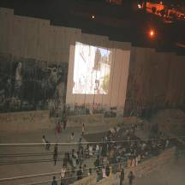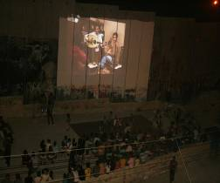

- Till Roesken a French volunteer came to Alrowwad during the months of August and worked on producing his film “Palestine”. He asked people from Aida Camp, to draw maps of how they see what is around them. The drawing process as well as the stories related to the maps has been recorded on video alongside with representations of the camp's history and its surroundings. The focus is on stories about difficult ways; about the obstacles that make it almost impossible to reach certain places and how people try and sometimes manage to get there anyway. This could be the first step of a study about the resistance by going around.
- From august 3 to 12 a group six participants came back from France after participating in 12 days activities in Bordeaux. In total 26 participants has been part of this great program. 22 of them are Palestinian refugees who came from different geographical areas. A group of six represented Alrowwad, another group came through Ajyal organization in Lebanon, another 5 came through Itijah organization in Palestine 48, and four through the General Union of Palestinian students (GUPS) senate in France. The main objective of this gathering is to enable Palestinian youths from different areas to talk about important issues as the Nakba and the Palestinian history so they will be better equipped to defend Palestinian refugees’ rights and work productively to get them. Several activities took place like Palestinian culture, ways of resistance, and the Zionist movement. During the gathering groups presented different shows that included traditional Palestinian dance – Dabka- and some theatre sketches.

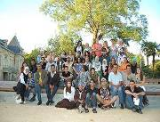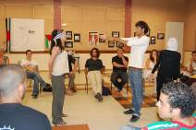

- During the last few months, Alrowwad Center welcomed more than 10 volunteers from different countries like France, Ireland, USA, and Belgium. They have been involved in several activities in different projects. We are expecting many others to come during the next few months.

